Title of the Paper (Times New Roman, 14 pt, Bold)
Name Surname, Name Surname, (Times New Roman, 12 pt, Bold)
Kaunas University of Technology (Times New Roman, 10 pt, Italic)
K. Donelaicio st. 73, LT-44029, Kaunas, Lithuania
E-mail. (Times New Roman, 10 pt, Italic)
Abstract (150 words, Times New Roman, 10 pt, Italic). The abstract of an article should be arranged in one column, 10 pt. The text is written in English with 1 interval spacing. Microsoft Word text editor should be used to prepare the article. The text should be laid out on the A4 format (210 x 297 mm) page with the following margins: top – 20 mm, bottom – 25 mm, left and right – 18 mm.
Articles should be between 8000 and 12000 words in length. This includes all text, such as the abstract, references, all text in tables, figures, and appendices.
Keywords: Not Less than 5 Keywords (Times New Roman, 10 pt, Italic)

Introduction and Titles of sections (Time New Roman, 10 pt, Bold)
Engineering Economics journal aims to publish empirical research that tests or extends economics and management theories and contributes to practice. All empirical methods, including, but not limited to, qualitative, quantitative, field, laboratory, meta-analytic, and mixed methods are welcome. To be published in EE, the research must make empirical and theoretical contributions, and the manuscript should highlight the relevance of those contributions to economic development or management practice. Authors should strive to produce original, insightful, interesting, important, and theoretically bold research that demonstrates a contribution to the field's understanding of an issue or topic.
An article's text should be arranged in two columns (width: 8,4 cm – spacing: 0,6 cm.) 10 pt.
The text should be written in English with 1 interval spacing. Each paragraph should start on a new line (0.6 cm).
For the citation of authors, use Latin letters only, e.g. (Morrison, 2011), (Morrison, 2011; Battilana & Lee, 2014) or (Backus et al., 2020).

Table 1 (9 pt)
The title of a table (9 pt, Bold)
Table information (9 pt) | Table information (9 pt) | Table information (9 pt)
Tables and figures should be placed as close as possible to where they are cited.
Tables and figures should be numbered separately and consecutively.
Table’s captions are typed in 9 points, centered, Times New Roman (style Table_caption).
Text in the tables is typed in 9 points, Times New Roman (style Table). An example of the table is given in Table 1.
Figure’s captions are typed in 9 points, centered, Times New Roman (style Figure_caption).
Tables and figures should be in black and white. An example of the figure is given in Figure 1.

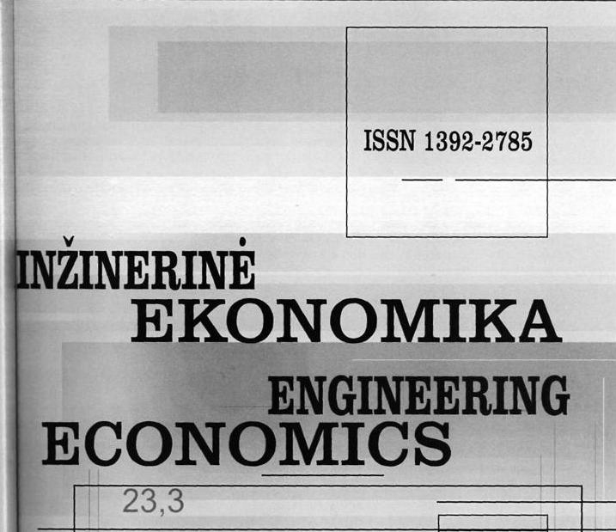
Figure 1. Title (9 pt)

Discussion (Times New Roman, 10 pt, Bold)
The authors should discuss the theoretical and practical contribution of the findings in this section
Conclusions (Times New Roman, 10 pt, Bold)
Findings of theoretical and empirical research.
Acknowledgment (Times New Roman, 10 pt, Bold)
Your article must reference all sources of external research funding in the acknowledgments section.

References (Times New Roman, 10pt, Bold)
The list of references is presented in one column (10 pt) according to the alphabet. References (not less than 25 resources applying APA format, wide use of ISI (http://www.isinet.com/isi/) and the list of cited research publications, e.g.:
Inzinerine Ekonomika-Engineering Economics, (all the references should be noted in the text of the article);
Here are some basic reference forms (journal article; book; book chapter, the Internet address), each publication should start on a new line (0,75 cm), the spacing between research publications is 3 mm, the text is written with an interval spacing, e. g.:
Journal article
Cygler, J., & Sroka, W. (2017). Coopetition disadvantages: The case of the high tech companies. Inzinerine Ekonomika-Engineering Economics, 28(5), 494–504.
Tamosiunas, A. (2010). Managing Corporate Strategic Changes in the Context of Climate Change. Inzinerine Ekonomika-Engineering Economics, 21(1), 19–31.
Zavadskas, E. K., Turskis, Z., Ustinovichius, L., & Shevchenko, G. (2010). Attributes Weights Determining Peculiarities in Multiple Attribute Decision Making Methods. Inzinerine Ekonomika-Engineering Economics, 21(1), 32–43.
Book
Nicol, A. A., & Pexman, P. M. (1999). Presenting your findings: A practical guide for creating tables. Washington, DC: American Psychological Association.
Book chapter
O’Neil, J. M., & Egan, J. (1992). Men’s and women’s gender role journeys: Metaphor for healing, transition, and transformation. In B. R. Wainrib (Ed.), Gender issues across the life cycle (pp. 107–123). New York: Springer.
The Internet address:
Pridotkiene, J., & Dapkus, M. (2011). The Model to Evaluate Risk Factors of Exporter-Provided Trade Credit. Inzinerine Ekonomika-Engineering Economics, 22(5), 477–484. Available from internet: http://www.inzeko.ktu.lt/index.php/EE/ article/view/966/1057

Authors’ biographies (Times New Roman, 10 pt, Bold)
The authors' biography should be presented in one column (10 pt). A brief professional biography of not more than 100 words should be supplied for each named author.
Annexes (Times New Roman, 10 pt, Bold)
Annexes must be numbered according to their appearance in the text.

